**Advance Excel Assignment 14**

Use the above dataset and answer the following questions. Assume that a gang is trying to loot Diamonds and Soft drinks being exported from India

1. How much Diamonds were looted from Chennai Port Trust?

Ans. 7182

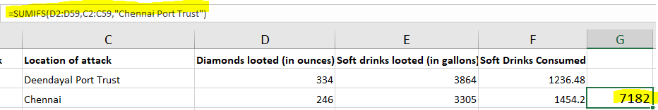

1. How many Ships were looted near Paradip Port Trust and Chennai Port Trust?

Ans. 6

1. What is the sum total of Diamonds looted from the V.O. Chidambarnar port trust?

Ans. 9887

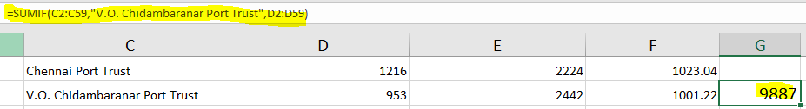

1. What is the average amount of Diamonds and Soft drinks looted?

Ans. 1741.31

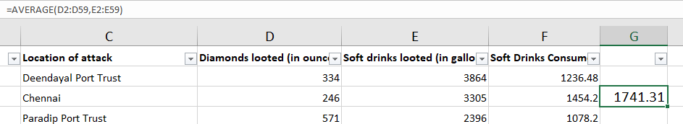

1. What is the ratio of soft drinks drunk to soft drinks looted?

Ans. 21535:8442